Project Report



***On***

**CAR LICENSE DETECTION VIA OCR (OPTICAL CHARACTER RECOGNITION)**

## Submitted for the requirement of Project

BACHELOR OF ENGINEERING IN

## COMPUTER SCIENCE ENGINEERING

**SUBMITTED BY:**

**BHAVYA THATHERA**

**20BCS9528**

**DEPARTMENT OF COMPUTER SCIENCE & ENGINEERING CHANDIGARH UNIVERSITY, GHARUAN**

**November 2022**



## BONAFIDE CERTIFICATE

Certified that this project report “Car License Detection via OCR (Optical Character Recognition)” is the Bonafide work of “BHAVYA THATHERA (20BCS9528)” who carried out the project work under our supervision.

**SIGNATURE SIGNATURE**

**Supervisor Head of Department**

Submitted for the project viva-voce examination held on:

**INTERNAL EXAMINER EXTERNAL EXAMINER**

**ABSTRACT**

License Platform Detection is a computer technology that enables us to identify digital images on the platform automatically. Different operations are covered in this system, such as imaging, number pad locations, alphanumeric character truncation and OCR. The final objective of the system is to construct and create efficient image processing procedures and techniques to position a licensing platter on the Open Computer View Library picture. It was used and implemented the K-NN algorithm and python programming language. The technology can be used in different industries such as security, highway speed detection, lighting violations, manuscript documents, automatic charging system, etc.

Auto plate recognition is an integrated technology which identifies the auto license plate. Auto plate auto recognition. Multiple applications include complex safety systems, public spaces, parking and urban traffic control. Automatic Vehicle License Plate Recognition (AVLPR) has undesirable aspects because of many effects, such as light and speed.

This work presents an alternative technique to leverage free software for the implementation of AVLPR systems including Python and the Open Computer Vision (openCV).

**TABLE OF CONTENT**

|  |  |  |
| --- | --- | --- |
| Sr no. | Topic | Page No. |
| 1 | Use of Modern tools in design and analysis | 5 - 6 |
| 2 | Discussion and report/results analysis | 7 - 8 |
| 3 | Project management and Professional communication (Presentation) | 9 - 14 |
| 4 | Attainment of stated outcomes | 14 |
| 5 | Certificate | 15 |

# Use of Modern tools in design and analysis

The Modern Tools used in this Project for Design and Analysis is Python. It is a Programming Language. It is used for web development (server-side), software development, mathematics, system scripting and many more.

Why Python?

* Python works on different platforms (Windows, Mac, Linux, Raspberry Pi, etc).
* Python has a simple syntax similar to the English language.
* Python has syntax that allows developers to write programs with fewer lines than some other programming languages.
* Python runs on an interpreter system, meaning that code can be executed as soon as it is written. This means that prototyping can be very quick.
* Python can be treated in a procedural way, an object-oriented way or a functional way.
* There are Some Libraries Used Here in this Project:

### OpenCV :

OpenCV is an open-source library for the computer vision. It provides the facility to the machine to recognize the faces or objects. In this tutorial we will learn the concept of OpenCV using the Python programming language.

There are two common ways to identify the images:

* 1. **Grayscale**

Grayscale images are those images which contain only two colors black and white. The contrast measurement of intensity is black treated as the weakest intensity, and white as the strongest intensity. When we use the grayscale image, the computer assigns each pixel value based on its level of darkness.

* 1. **RGB**

An RGB is a combination of the red, green, blue color which together makes a new color. The computer retrieves that value from each pixel and puts the results in an array to be interpreted.

Here, In this Project, We are Using GreyScale Technique to identify whether the Space if empty or filled by using pixel approach.

**Easy-ORC:**

Easy OCR is a font-dependent printed character reader based on a template matching algorithm.

It has been designed to read any kind of short text (part numbers, serial numbers, expiry dates,

manufacturing dates, lot codes, …) printed on labels or directly on parts.

**Numpy:**

NumPy is a Python library used for working with arrays. It also has functions for working in domain of linear algebra, Fourier transform, and matrices.

NumPy was created in 2005 by Travis Oliphant. It is an open-source project and you can use it freely.

NumPy stands for Numerical Python.

## CVZone:

Cvzone is the library that develops a bridge between Arduino and python. With the help of the SerialObject module in Cvzone we can connect the arduino port with python as well as send data to arduino and can link any python code with it.

**Software Requirements:**

* Windows 7 or higher.
* SQL 2008 or higher.
* Visual studio 2010, Python Environment.

**Hardware Components:**

* Processor – i3(Min).
* Hard Disk – 50 GB.
* Memory – 3 GB RAM.

# Discussion and report/results analysis

**Overview:**

This project which we have made with the help of AI gives us a brief understanding of OCR (Optical Character Recognition). This helps us detect the number of plates of the car and at the same time this prints out the license number and the name of the owner of the vehicle. This will have a huge impact on the upcoming ai generations because we are moving towards a paper-free future and this will surely reduce the paperwork and make things easy and simple for the user with its easy-to-use interface. To operate this program the user should have a slight knowledge of the computer and inputting the image in the program.

**Goal:**

1. To make people follow traffic rules.

2. To help the crime handling agencies in finding stolen vehicles.

3. To help the government’s pollution checkpoints to keep a proper record of old vehicles which shouldn‘t be used to due to the amount of pollution they are responsible for.

4. To decrease the amount of paperwork done on vehicle-related issues.

5. To make the data processing faster in vehicle-related issues as all the things will be stored in a particular database.

**Advantages:**

1. This project decreases the time consumption of a person.

2. Easy to use.

3. Easy to access the data.

4. Helps for the benefit of society.

5. Might lead to depression in the stealing vehicles.

6. User friendly.

7. And many more.

# License Plate Recognition System (LPRS)

# 

# Project management and Professional communication

**(Presentation)**

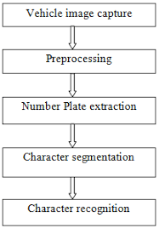

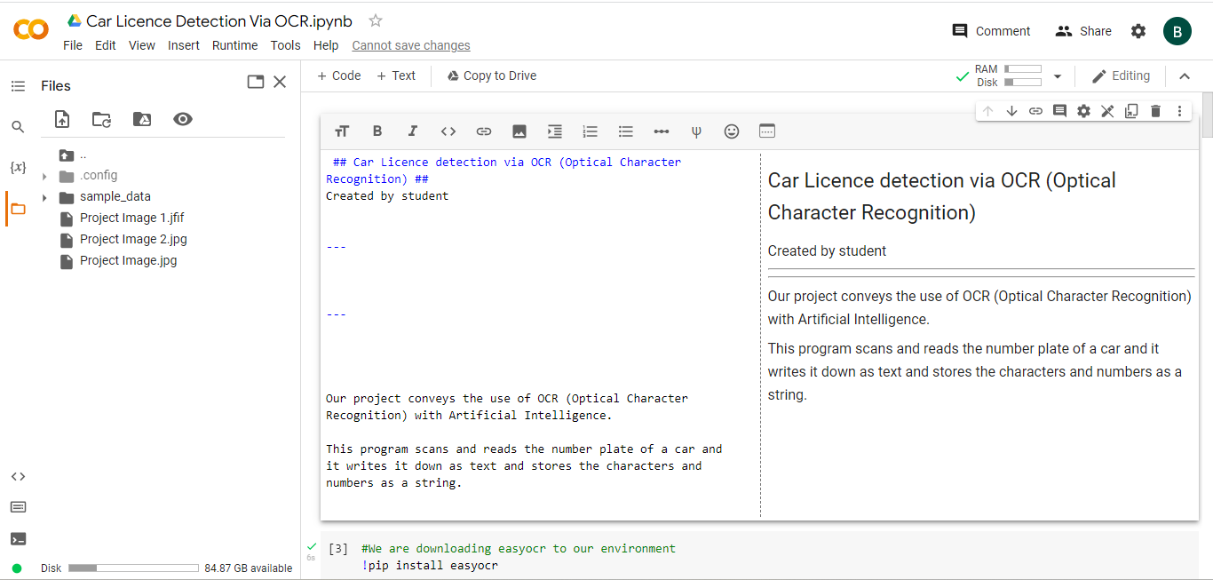

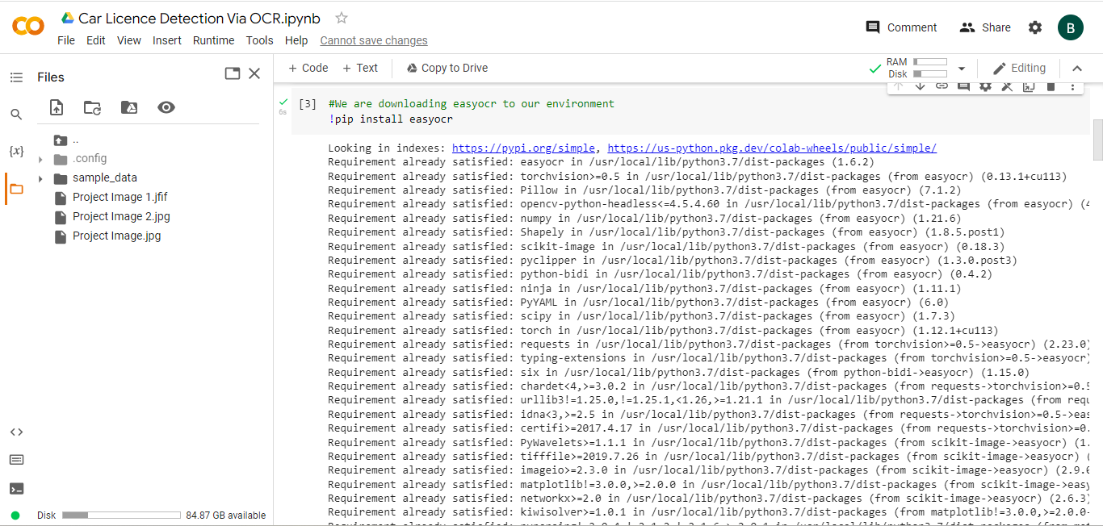

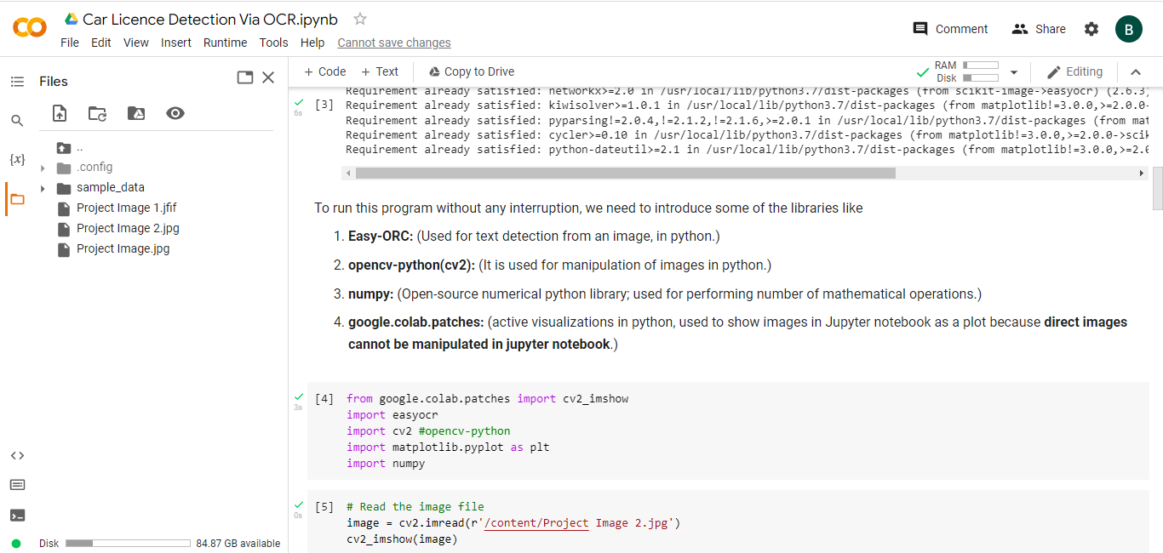

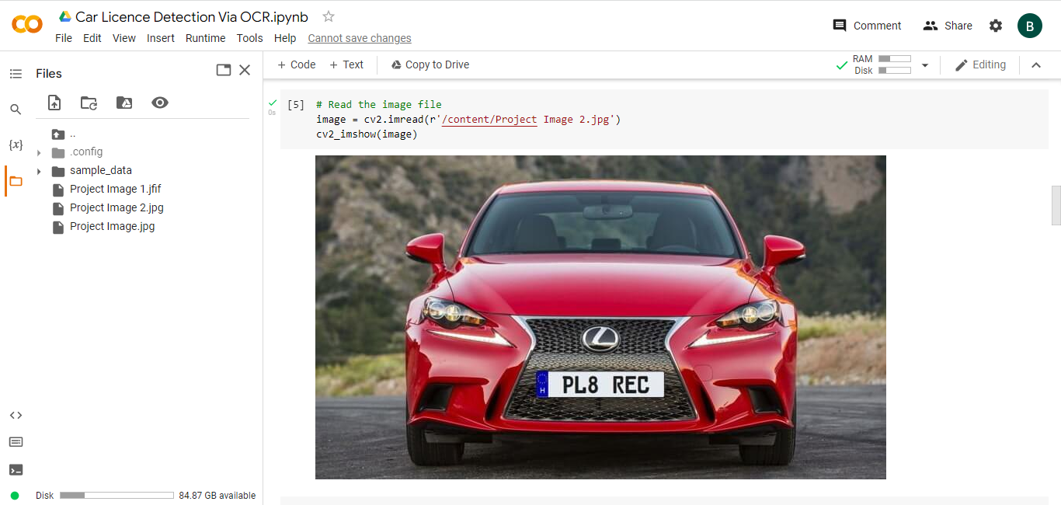

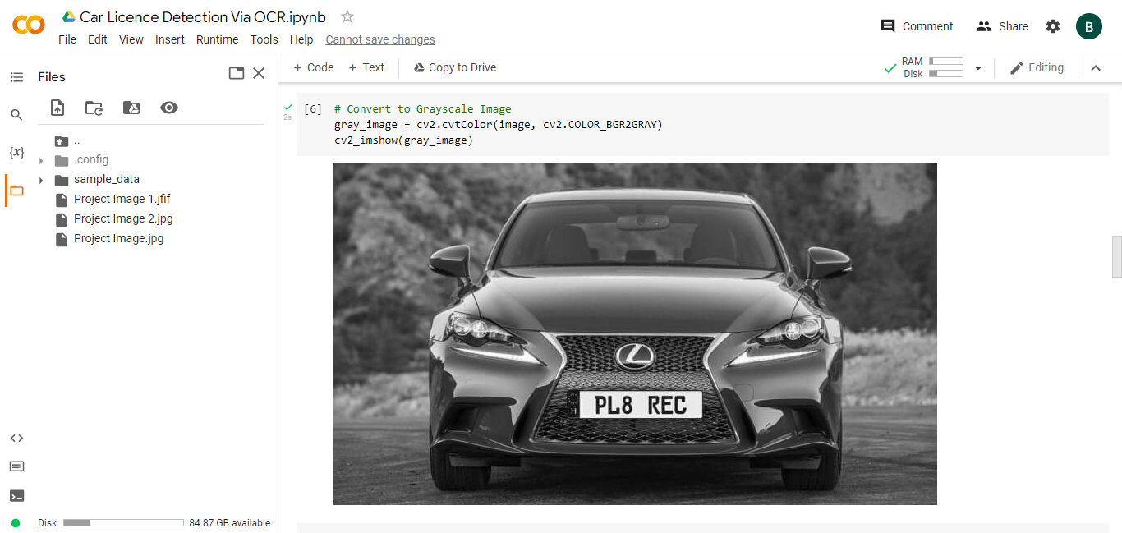

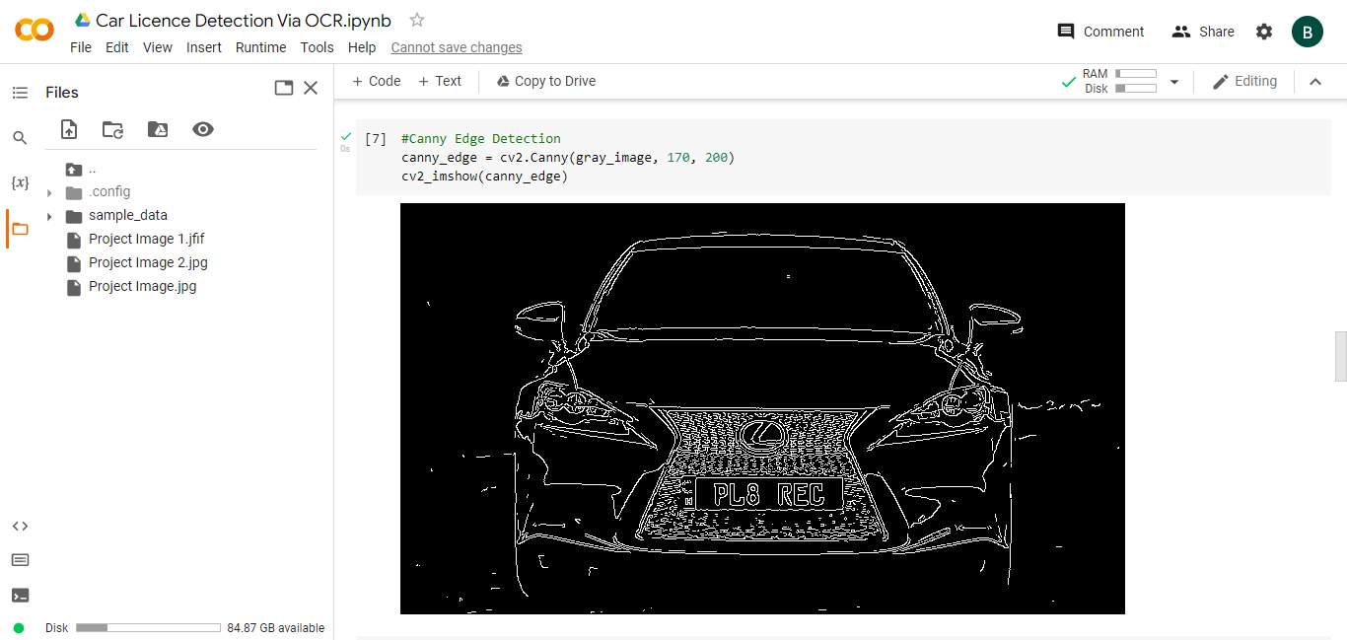

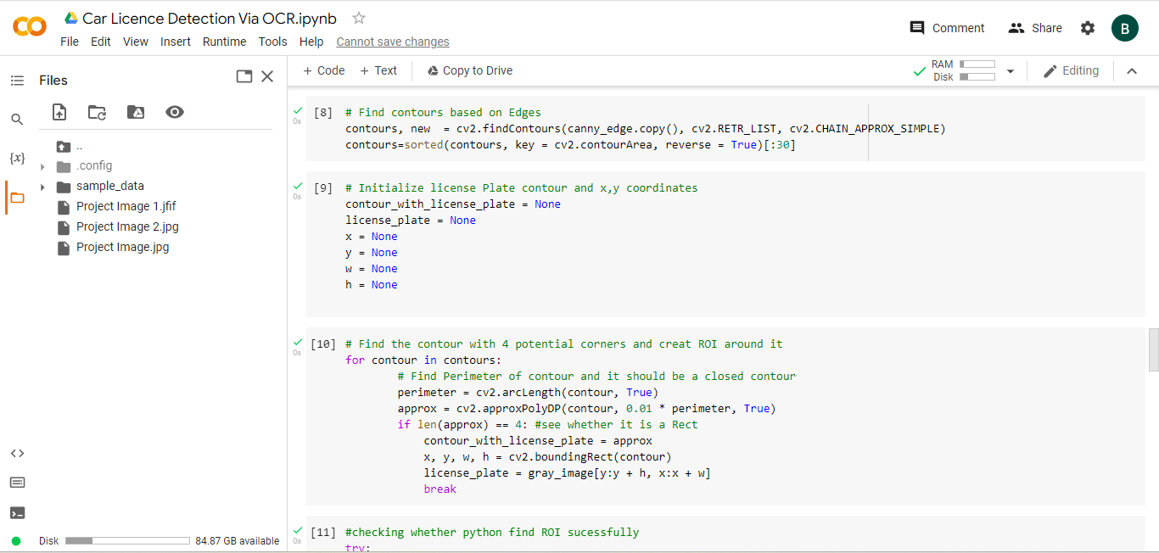

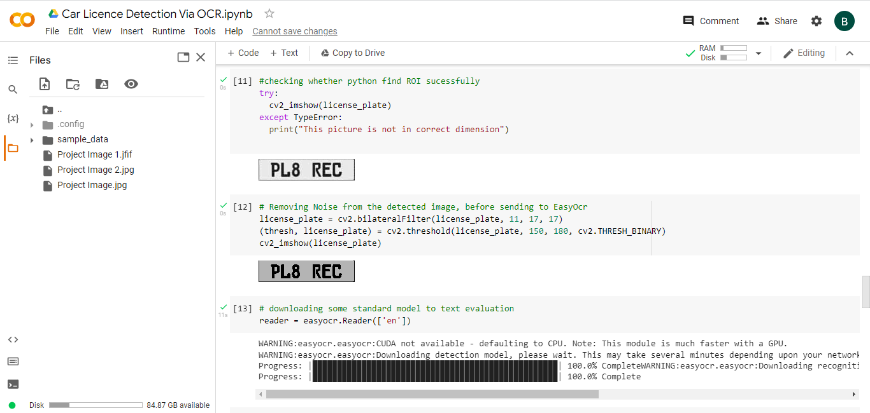

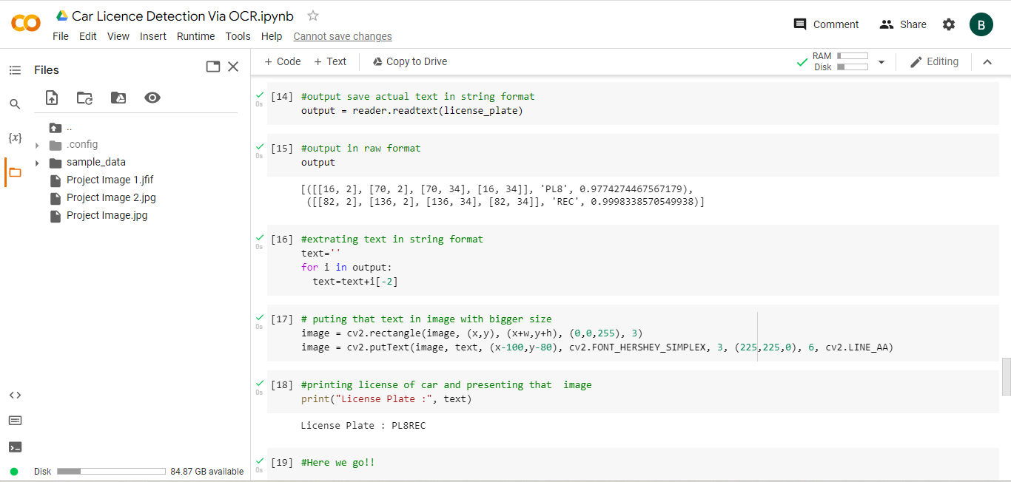

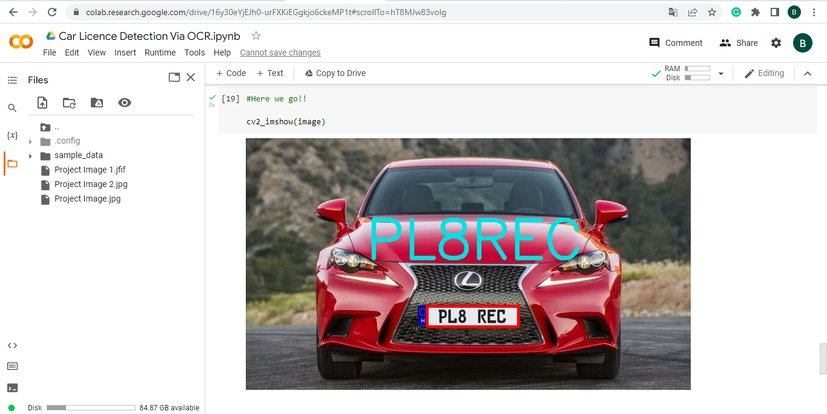

# Attainment of stated outcomes

* Verifying the ownership of the vehicle (Law Enforcement Purposes).
* Used at parking lots for the ease of finding someone’s vehicle.
* Useful for faster processing of plate numbers at the service centres or at the Pollution Check Points.
* Keeping the track of vehicles passed at the toll points at National and Express Highways.
* Security Purposes (Automatic Registration of Vehicle Number Plate via CCTV Footages).
* Reduction of the amount of Paperwork.

